Tofu Tower Defence

Joshua Kouri
Sophia Kim

Table of Contents
Preamble 2
Terminology 2
Design 2
Overview 2
Gameplay 2
Cats & Difficulty Settings 4
Towers 4
Enemies 6
Appendix 6

Preamble
This document contains information about Tofu’s Tower Defence, a video game inspired by our cat, Tofu. Henceforth, Tofu’s Tower Defence will be referred to as TTD.

Terminology
Term | Definition
BTD | Bloons Tower Defense, a popular tower defence game.
Cat | The “heart” of the player’s defences which must be defended at all times!
Pregame | The period between starting a level and before starting the first wave.
TD | Shorthand for “Tower Defence [video game]”.
Tile | A single hexagonal on the hexagonal grid which makes up the map.
Towers | A defensive unit constructed by the player.
TTD | Tofu’s Tower Defence.
World | A collection of levels unified by a single theme or plot point.

Design

Overview
The basic gameplay loop will consist of several, escalating waves of enemies attacking the player character’s cat. If the cat takes too much damage, it will be roused from its sleep and run away. Cotton and fabric can be harvested to build defences (stuffed animals) which will defend the cat. Defeating enemies will yield XP (experience) which can be used to purchase promotions for your defences.

Gameplay
TTD will be similar to the archetypal tower defence game; defend a “home base” (the cat) against waves of enemies by strategically managing resources to construct defences. Contrasting TTD against BTD (Bloons Tower Defence), TTD is notable for:
- The lack of a single “path” for enemies to travel along, allowing enemies to attack and destroy defensive installations.
- Splitting the currency(s) required to build towers and the resource yield dropped by enemies into separate currencies. The intention behind this decision is to create a dilemma for the player; how aggressively can the player gather resources without jeopardizing their position?
- The lack of a qualified developer.
- The inclusion of cats.
TTD takes place on a grid of hexagonal tiles. Each tile will have its own unique elevation, ranging from 0.0 – 3.0, increasing in 0.5 increments. Some tiles have resources on them, such as pillows, shirts, or mattresses. Some tiles look suspiciously different from regular tiles; these are called “spawning tiles”. These “spawning tiles” will be covered later.
A game of TTD flows between the following states: pregame, mid-wave, post-wave, and postgame.
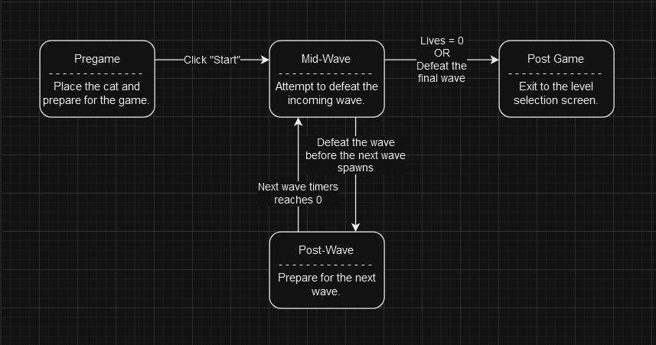
Figure 1 - TTD gameplay state diagram.
During the pregame, the player must do the following:
- Place the cat. It is impossible for the defensive units to remain motivated in their defence without the cat sleeping peacefully. Thus, the cat must be placed somewhere far from the fighting and defended at all costs!
- Place towers. The player will begin with a small amount of cotton and fabric. All towers require some amount of cotton and cotton to construct, so the player must be careful with how they choose to spend their limited resources.
Once the player decides their defences are sufficient, the player will click the “Start” button. At this point, the player will enter the mid-wave game state. During the mid-wave game state, enemies will spawn on suspicious tiles and attack the nearest target. The player may still build towers during the mid-wave. Each wave will last for a certain amount of time (e.g. 60 seconds). If the player defeats the wave before this time window expires, a brief delay will occur before the next round starts and any tower time-based events, such as ability recharges, will be accelerated. If the player does not defeat the wave before the wave timer expires, the next wave will spawn regardless of the number of enemies remaining from the previous wave.
If a tower capable of harvesting resources is placed on a resource, such as a shirt, that tower will harvest fabric and/or cotton from that resource after the pregame ends. Whenever an enemy is killed, that enemy will drop XP. XP can be used to purchase promotions for towers which will make the tower more useful.
Once the player either defeats all waves or loses all their lives, the game ends. If the player defeated all waves, the next level will be unlocked. If the player lost, they would not unlock the next level.

Cats & Difficulty Settings
Only one cat is available for placement for each level. The cat available for placement is determined before each game starts when the player selects the level difficulty.
Table 1 - Difficulty settings.
Difficulty | Enemy Health Modifier | Enemy Speed Modifier | Resource Collection Modifier | Cat
Beginner | 90% | 90% | 90% | Tofu, a small, fluffy white kitten (occupies 1 tile).
Amateur | 100% | 100% | 100% | Phonsi, a mid-sized, short-haired grey cat (occupies 3 tiles).
Master | 110% | 110% | 110% | Dolly, a large, fluffy white and brown cat (occupies 7 tiles).

Towers

Menacing Monkey
The Menacing Monkey is a small, plush monkey which delivers reliable damage output and range for an affordable cost. The Menacing Monkey chucks bananas at enemies and can be upgraded to unlock a terrifying ability, Gordy, which allows this tower to briefly double its attack rate.
Attribute | Value | Notes
Health | 250
Cost | 75 fabric, 25 cotton
Size | 1 tile
Range | 2
Attack(s) | Banana Barrage  - Attack Speed: 1.00 seconds/projectile.  - Damage per Projectile: 40-60  - Damage Type: Bludgeoning  - Range: Same as tower
Promotions | Improved Range I  - Dependencies: None  - Cost: 100 XP  - Increase range by 1.  Improved Range II  - Dependencies: Improved Range I  - Cost: 150 XP  - Increase range by 1.  More Bananas  - Dependencies: None  - Cost: 175 XP  - Increases attack speed to 0.66 seconds/projectile.  Gordy  - Dependencies: Improved Range II, More Bananas  - Cost: 400 XP  - Unlocks the ability, Gordy. Doubles attack speed for 10 seconds. Cooldown of 45 seconds.

Digging Donkey
The Digging Donkey is the primary harvesting unit. When placed on a resource, the Digging Donkey will begin to harvest that resource and automatically add the amount generated to the player’s totals.
Attribute | Value | Notes
Health | 300
Cost | 50 fabric, 50 cotton
Size | 1 tile
Range | 1
Attack(s) | Shovel Smack  - Attack Speed: 5.00 seconds/attack  - Damage per Attack: 60-80  - Damage Type: Piercing  - Range: Melee  - When the Digging Donkey is prepared to use Shovel Smack but no enemies are in range, the Digging Donkey will instead use its attack to harvest resources.
Promotions | Bigger Shovel I  - Dependencies: None  - Cost: 250 XP  - Increases Shovel Smack damage by 20.  - Increases resource collection by 50%.  Bigger Shovel II  - Dependencies: None  - Cost: 400 XP  - Increases Shovel Smack damage by 20.  - Increases resource collection by 50%.

Enemies

Dust Bunnies (Spearmen)
Dust Bunnies (Spearmen) are weak units capable of overwhelming defences through sheer numbers.
Attribute | Value | Notes
Health | 100
Size | 1
Speed | 3.0 seconds/tile
Attack(s) | Headbutt  - Attack Speed: 0.75 seconds/attack  - Damage per Attack: 25  - Damage Type: Bludgeoning  - Range: Melee

Dust Bunnies (Archers)
Dust Bunnies (Archers) are weak units capable of overwhelming defences through sheer numbers.
Attribute | Value | Notes
Health | 70
Size | 1
Speed | 2.5 seconds/tile
Attack(s) | Piercing Shot  - Attack Speed: 1.50 seconds/attack  - Damage per Attack: 20  - Damage Type: Piercing  - Range: 2

Appendix
Table 2 - Damage types.
Damage Types | Description
Acid
Bludgeoning
Cold
Fire
Force
Lightning
Necrotic
Piercing
Poison
Psychic
Radiant
Slashing
Thunder
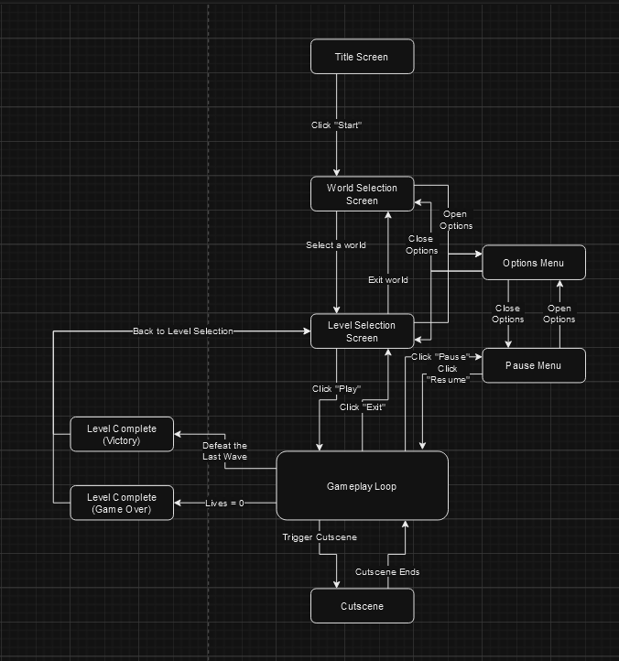
Figure 2 - Game state flow chart.

I (Joshua) use BTD as a reference point since it is both 1) One of the most popular games in the TD genre and 2) BTD is the TD game I have the most experience with.

